MEETING AGENDA

Topic:

Thursday, January 30, 2020

10:30-11:30

Attendees: (All Team Members)

Please bring: CAD models for parts that are under revision, links to part pages

11:00 | Review previous weeks assignments  - Each team member will provide a status update for their assignments from the previous week  - Discuss progress of assignments and what is needed
11:15 | Status of the manufacturing/hardware review  - Schedule  - Parts and supplies  - What parts are will be constructed by team vs ordered  - Are designs ready for parts that need ordering  - Hip belt  - Knee Brace  - Any 3D printed parts that are needed  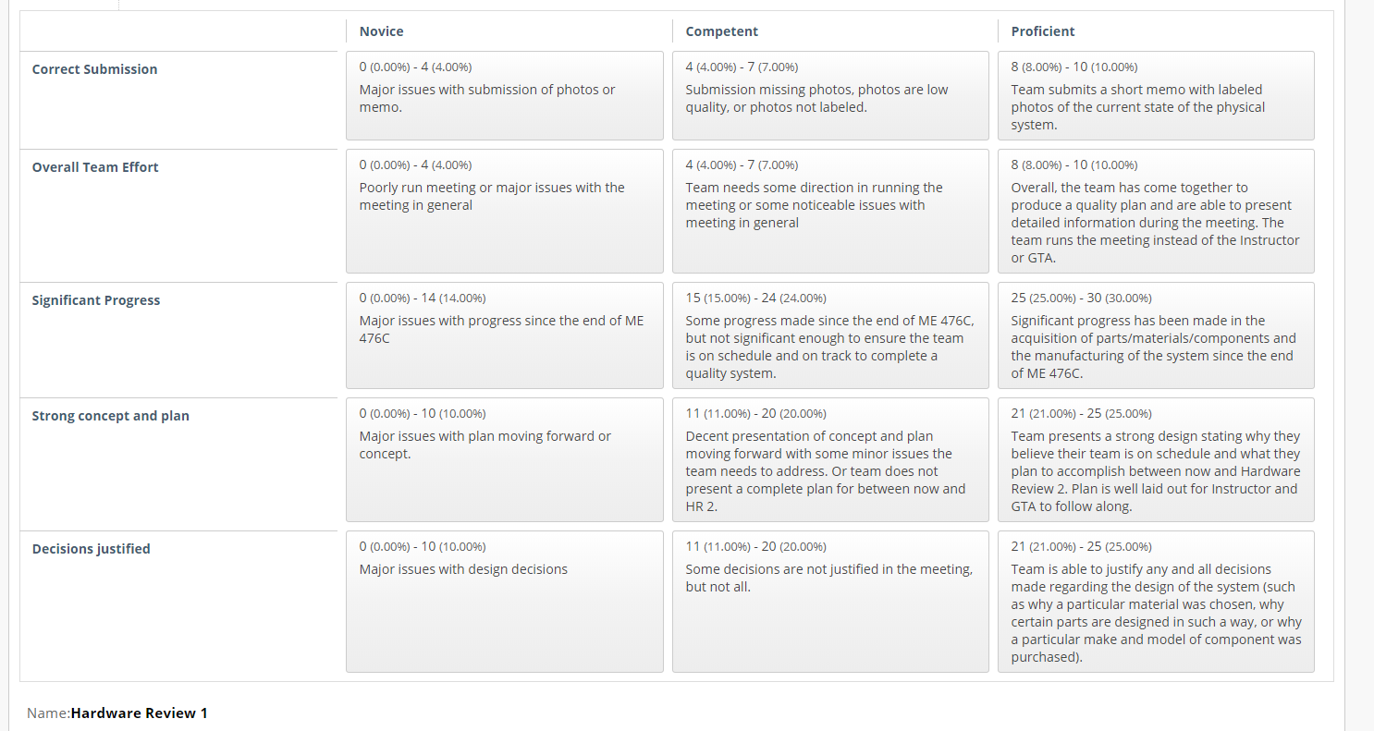
11:40 | Engineering requirements/changing to testing procedures assignment  - Team can bring to the floor what questions they have about the assignment  Assignment description on bblearn:  Teams will submit a memo detailing any and all changes to the Engineering requirements of the project and subsequent changes to the Testing Procedures. All testing procedures must be outlined in the memo, with detailed information regarding exactly how the tests will be run, WHERE teams will get the equipment, and when the tests will be performed.
Remaining minutes | Delegate individual assignments

